**Name:- Dharan Gowda Superset id:-6387532**

**Create a React Application “eventexamplesapp” to handle various events of the form elements in HTML.**

1. **Create “Increment” button to increase the value of the counter and “Decrement” button to decrease the value of the counter. The “Increase” button should invoke multiple methods.** 
   1. **To increment the value**
   2. **Say Hello followed by a static message.**

**Step 1: Create the React App(eventexamplesapp)**

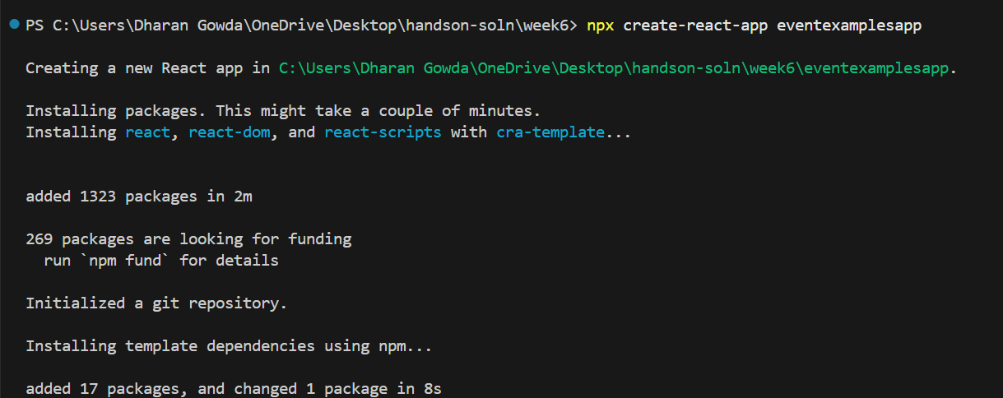

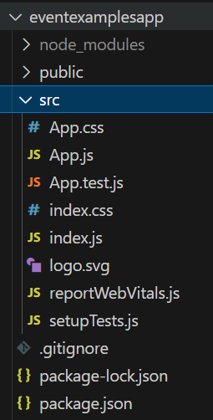

**Step 2: Create components/CounterComponent.js**

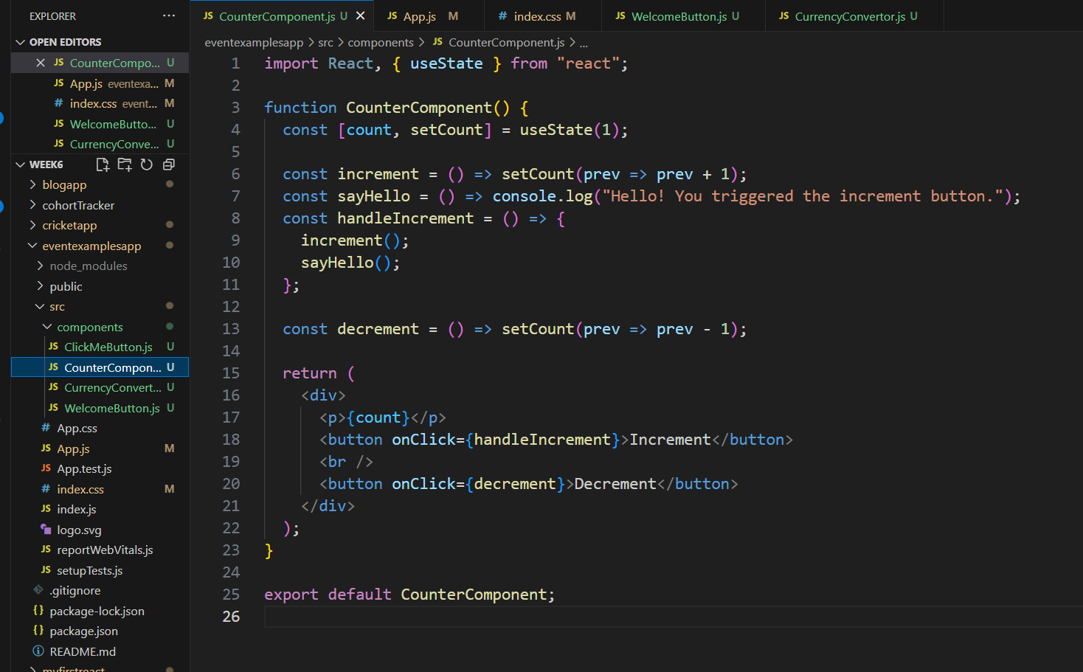

**OUTPUT:-**

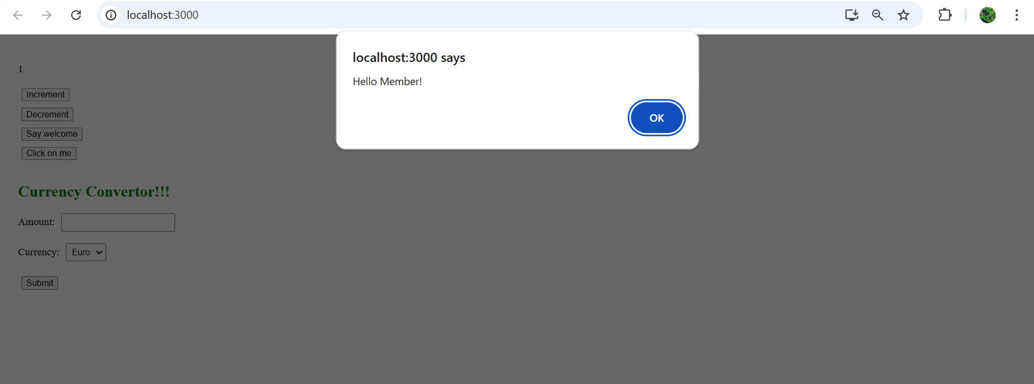

1. **Create a button “Say Welcome” which invokes the function which takes “welcome” as an argument.**

**Step 1: Create components/** **WelcomeButton.js**

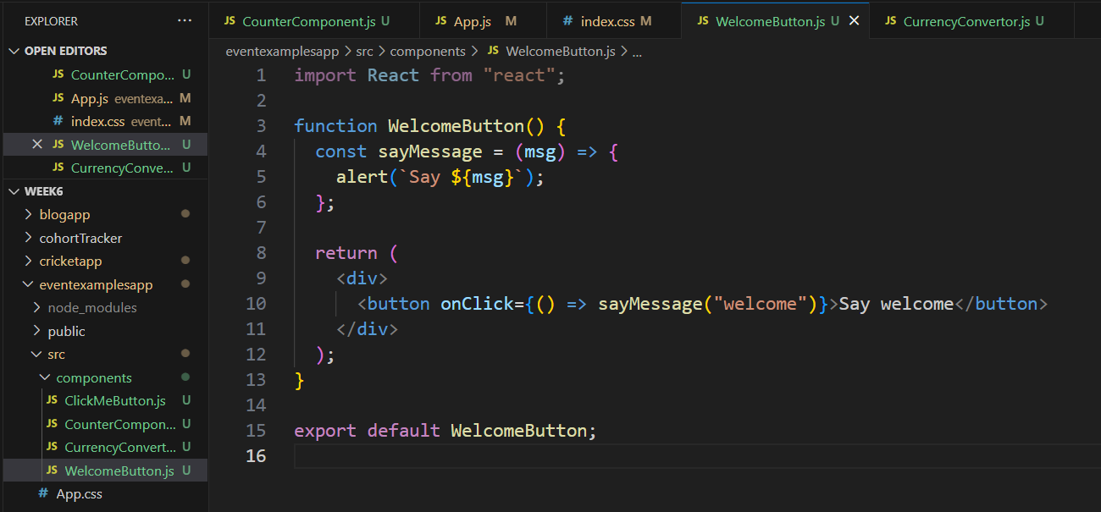

**OUTPUT:-**

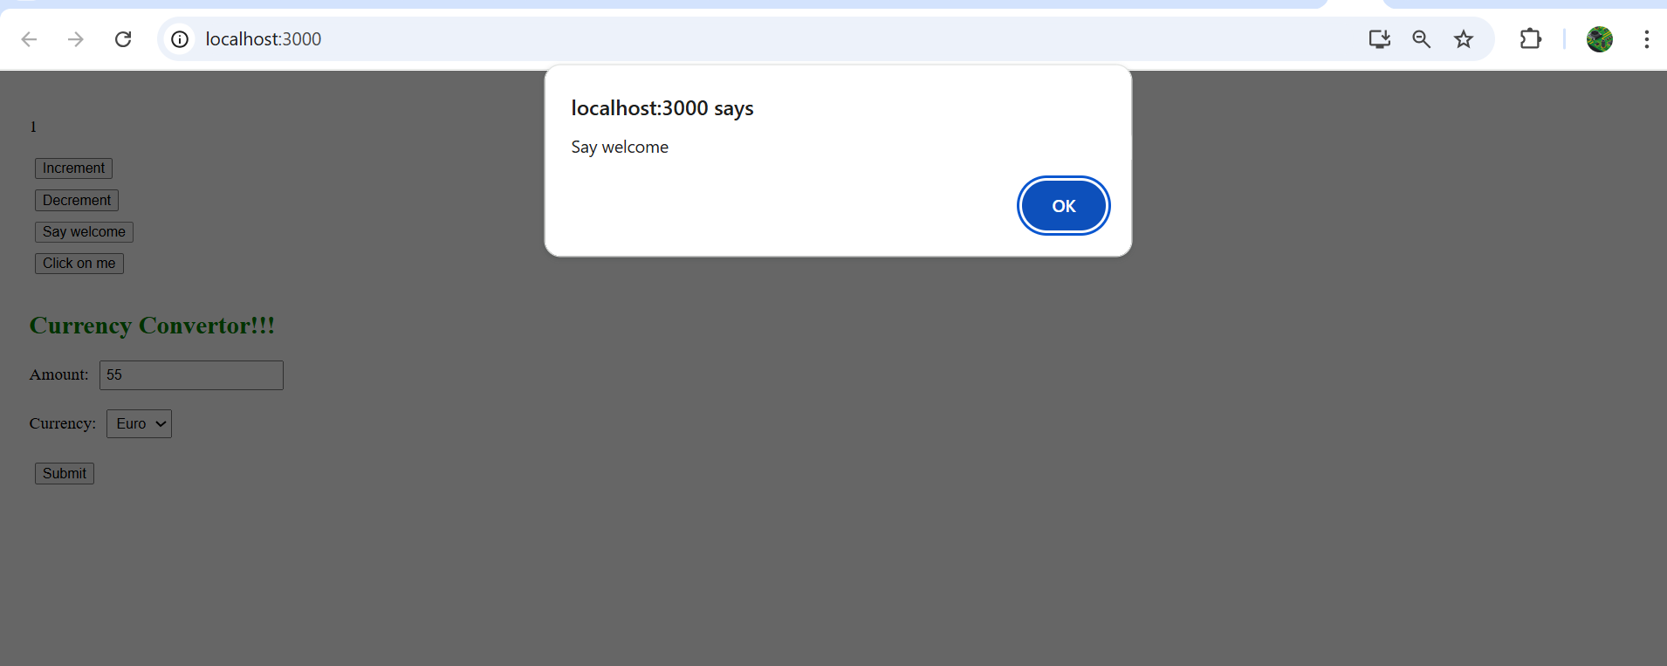

**3 . Create a button which invokes synthetic event “OnPress” which display “I was clicked”**

**Step 1: Create components/ ClickMeButton.js**

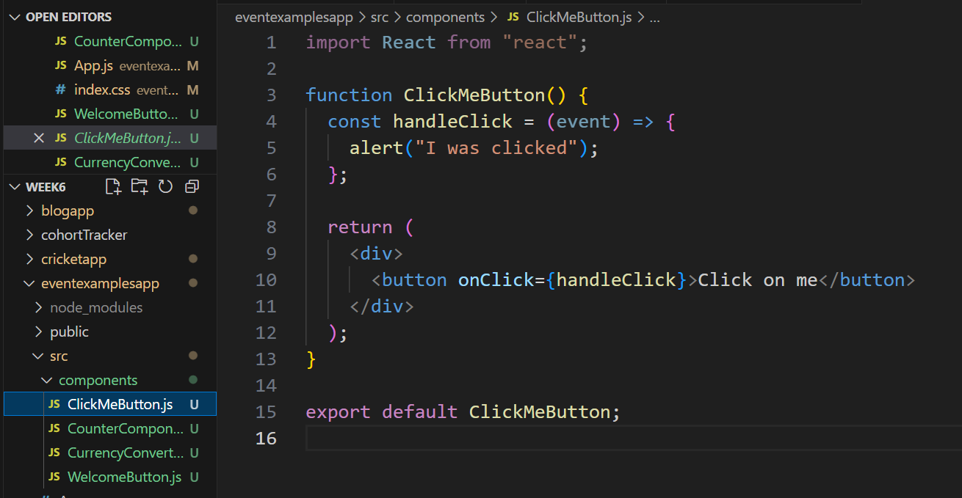

**OUTPUT:-**

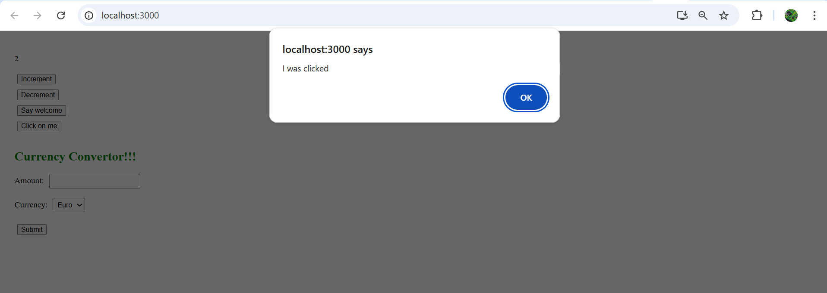

**4 .Create a “CurrencyConvertor” component which will convert the Indian Rupees to Euro when the Convert button is clicked.**

**Handle the Click event of the button to invoke the handleSubmit event and handle the conversion of the euro to rupees.**

**Step 1: Create components/ CurrencyConvertor.js**

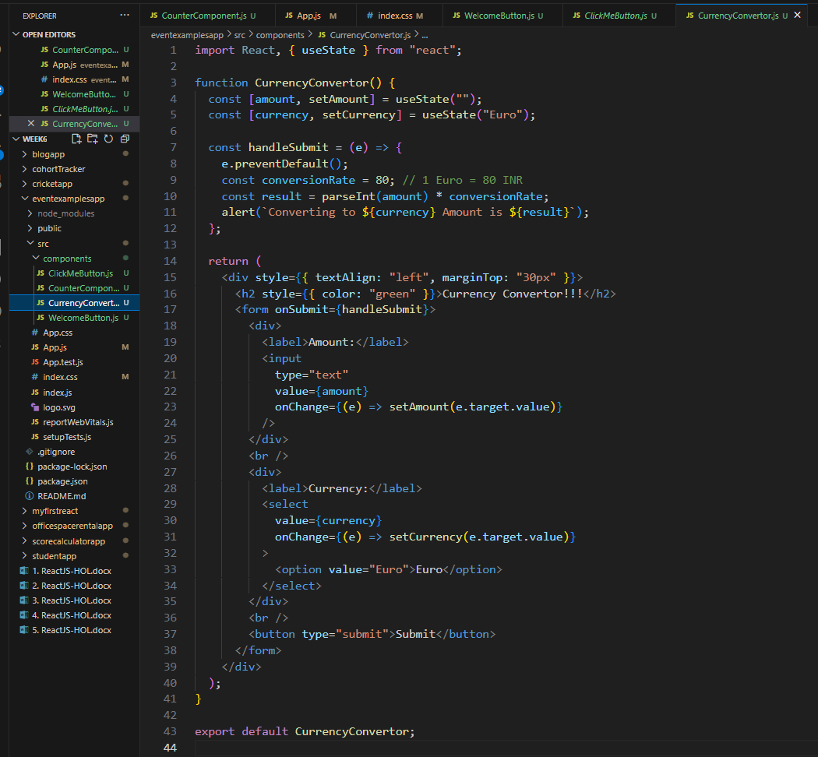

**OUTPUT:-**

